Lab#10 Create a responsive web page of your Product page using Tailwind CSS only.

TAGS USED | DESCRIPTION
<!DOCTYPE html> | Declares the document as an HTML5 document.
<html> | Root element of the HTML document.
<head> | Contains metadata and information about the HTML document.
<title> | Specifies the title shown in the browser tab.
<script> | Links the Tailwind CSS CDN to the HTML document.
<body> | Contains all visible content of the webpage.
<header> | Defines the header section of the webpage.
<div> | Groups elements and uses Flexbox to align items.
<h1> | Defines the main heading or store logo, “niki's store”.
<nav> | Defines the navigation section of the webpage.
<a> | Defines hyperlinks such as Home, About, Contact, Laptop, Mobile, and Shoes.
<button> | Creates the Products dropdown button.
<div class="relative group"> | Creates a parent container for the dropdown menu.
<div class="hidden group-hover:block"> | Hides the dropdown menu until the user hovers over it.
class="bg-orange-600" | Sets the header background color to orange.
class="text-white" | Sets the text color to white.
class="p-4" | Adds padding around the header content.
class="flex justify-between items-center" | Arranges the logo and navigation horizontally with space between them and vertically centers them.
class="text-2xl font-bold" | Makes the store logo larger and bold.
class="flex gap-6" | Arranges navigation links horizontally with spacing between them.
class="hover:text-purple-800" | Changes the text color to purple when the user hovers over a link or button.
class="absolute bg-white text-black p-2 w-32" | Positions and styles the dropdown menu with a white background, black text, padding, and fixed width.
class="block p-2 hover:bg-gray-200" | Displays dropdown links as blocks and changes their background color on hover.

Final Outcome:

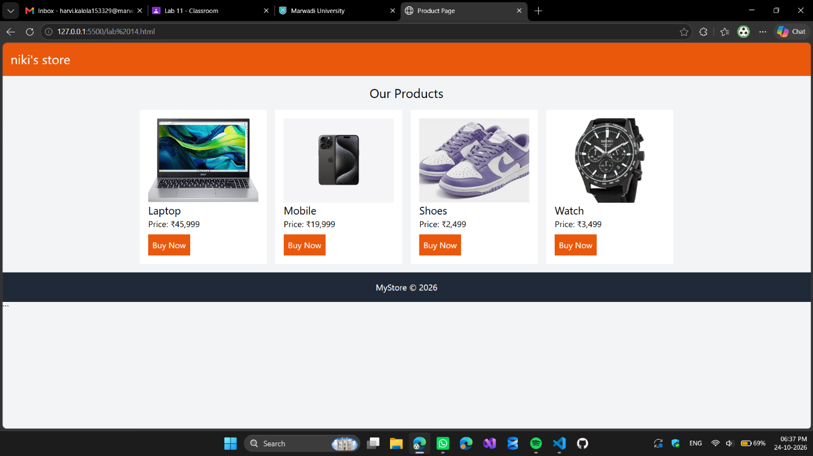

Code Snippet:

<!DOCTYPE html>
<html>
<head>
<title>Product Page</title>
<script src="https://cdn.tailwindcss.com"></script>
</head>

<body class="bg-gray-100">

<!-- Header -->
<header class="bg-orange-600 text-white p-4">
<h1 class="text-2xl">niki's store</h1>
</header>

<!-- Products -->
<div class="p-4">
<h2 class="text-2xl text-center mb-4">Our Products</h2>

<div class="flex flex-wrap justify-center gap-4">

<!-- Product 1 -->
<div class="bg-white p-4 w-60">
<img src="laptop.webp" class="w-full h-40 object-cover">
<h3 class="text-xl">Laptop</h3>
<p>Price: ₹45,999</p>
<button class="bg-orange-600 text-white p-2 mt-2">Buy Now</button>
</div>

<!-- Product 2 -->
<div class="bg-white p-4 w-60">
<img src="phone.webp" class="w-full h-40 object-cover">
<h3 class="text-xl">Mobile</h3>
<p>Price: ₹19,999</p>
<button class="bg-orange-600 text-white p-2 mt-2">Buy Now</button>
</div>

<!-- Product 3 -->
<div class="bg-white p-4 w-60">
<img src="shoes.webp" class="w-full h-40 object-cover">
<h3 class="text-xl">Shoes</h3>
<p>Price: ₹2,499</p>
<button class="bg-orange-600 text-white p-2 mt-2">Buy Now</button>
</div>

<!-- Product 4 -->
<div class="bg-white p-4 w-60">
<img src="watch.webp" class="w-full h-40 object-cover">
<h3 class="text-xl">Watch</h3>
<p>Price: ₹3,499</p>
<button class="bg-orange-600 text-white p-2 mt-2">Buy Now</button>
</div>

</div>
</div>

<!-- Footer -->
<footer class="bg-gray-800 text-white text-center p-4">
MyStore © 2026
</footer>

</body>
</html>

